**The following is information I have as of March 8, 2011**

Maker: Paul Pouvillon, (1878-1969) Born in Nogent-sur-Oise. In 1896 he was awarded a bronze medal at the Besanon exhibition and in 1902 he settled in his home town at 48 General de Gaulle Street. He was awarded a silver medal in Paris in 1939 for his planetary clock (Tardy writes of him succinctly - 'Il fit une horloge astronomique') with the title 'Meilleur Ouvrier de France'. He was made 'Chevalier de la Legion d'Honneur in 1948. According to Miclet (op. cit.) Pouvillon started work on this clock in 1930 and finished in 1939 but was still carrying out further improvements in 1948.

Origin: Nogent-sur-Oise, France

Date: Begun 1930, finished 1939

Literature: French newspaper article dated from c. 1953 (source unknown).**1** French newspaper article, 20 February 1955, Le Parisien.**2** Bernard Miclet, 'Paul Pouvillon M.O.F. et son horloge à planetaire', Bulletin of A.N.C.A.H.A., No.43, summer 1985.**3** Derek Roberts, *Continental and American Skeleton Clocks*, Atglen, 1988, p. 122, figs. 116a, b, c.

Provenance: Clock dealer Jean-Pierre Rochefort, 14 Rue de Saints Péres, 75007 Paris, France. Advertisements by his firm for this clock were posted in Antiquarian Horology, September 1983, page 325, December 1983, page 346, March 1984, page 462. Antiquorum Geneva, 22 April 1995, lot 162, (CHF. 220,000 $149,660). Chrisite’s, London, 9, December 2010, lot 231, (BPS 120,000, $180,000)

Description: CASE: glazed brass case with door to front and on stepped and moulded ebonised plinth, also with door to front and with paneled sides, its top with a plaque engraved 'POUVILLON/NOGENT SUR OISE' FRONT DIALS: main chapter ring showing mean solar time for the meridians of London and Paris, with actual local time and sweep seconds; a Houdin type 'mystery' dial above showing solar time ('Temps Vrai'); a leap year indication dial behind LEFT SIDE DIALS: three dials showing month of year, season of year and zodiacal month; skeletonized ring below showing time of sunrise and sunset with the sun's elevation, the length of day and the length of night indicated on subsidiary rings; a group of dials below forming an 'Ecclesiastical computer' and showing the Dominical letter, the Epact, the Golden number, the Solar cycle, the day of the week for the next 1 January and the date of Easter RIGHT SIDE DIALS: three dials showing unequal hours, the day of the week and the day's planet; above a lunar dial, its hand set with a painted bone moon revolving to indicate its visible phases, the outer ring calibrated to show its age; a planisphere below with revolving plexiglass centre painted to show the principal constellations of the northern hemisphere at approximately 49 degrees, within a ring showing the sidereal day ORRERY: incorporating an annual calendar ring with the signs of the zodiac, steel pointers indicating the stages of Easter, the Earth with coloured paper gores and revolving on its own tilted axis (painted moon with day and night now lacking) and with gilt-metal sun; with gearing for all the planets (the planetary mounts now lacking) MOVEMENT: raised on two substantial tapering steel columns, the substantial lead weights with integral pulleys housed in the plinth, with Graham-type pallets for dead beat pinwheel escapement, count wheel strike on pendulum; fine regulation for the wood-rod pendulum with substantial gilt-steel bob  
58 in. (147 cm.) high; 22 in. (56 cm.) wide; 18½ in. (47 cm.) deep

**1. Newspaper article dated from 1953, larger file available for direct reading.**



**Below is a translation of the newspaper article on the prior page, 1953.**

**M. Pouvillon finished his planetary clock, his life work.**

His clock is finished, Mr. Pouvillon asked heaven to grant him one more year to live, and today no more prayers are needed. Now his clock has been realized and his life in has not been wasted.

At a little house in the old section of Nogent there is a nice garden with several solar dials displayed around the yard. A workshop with hundreds of clocks with all of them running. The tic toc's could be hear from outside. We are in the work environment of France’s best workman ship. *(Because of this clock Pouvillon received the coveted award "Meilleur Ouvrier de France” or "Best Craftsman of France” in 1939.)* Every tic toc heard maybe monotone to some, but to Mr. Pouvillon the sound was marvelous to his ears, the sound alone opens his imagination in visualizing all the thousands of wheels at work.All of the gears interlocking together, with the constant notion of time maintained by a spring.

Once we get to the 48 General de Gaulle Street, the goal is not mentioned. But one soon realizes it is to admire and understand and display this time piece that is museum worthy.

The planetary clock has been finished and here it is the part that I have been looking for!

Mr. Pouvillon can't hide his enthusiasm and with his gentle gestures; with all the years spent working with clocks, this time piece encapsulate all of his time spent as a master horologist.

This large mass of wheels and spinning balls along with all the steel allow us to visualize how the quantum perpetual is triggered followed by the ecclesiastical Easter day indicator. *(This is the ecclesiastical calculator or ‘computus’ that predicts the date which Easter will fall as well as several other dominical statistics.)* On the same piece, is mounted a system that gives the earth prospective, with all its daily variations in relation with the sun viewed from above. *(This is the tellurium, showing the Sun, Earth, Moon system.)*

Toy for a child, toy for a grownup, museum piece, scientific instrument. Not only a true personal master piece and magical that speaks and lives. This piece made Pouvillon a man comparable to Dasypodius or Schwilgué. These clock makers made the infamous Strasbourg clock being the seventh marvel of the world. *(Dasypodius designed the first astronomical clock for the Strasbourg Cathedral which was built by Isaac Habrecht 1572-1574. Jean-Baptiste Schwilgué built the current cathedral clock 1838-1843.)*

This planetary clock that we have before our eyes is more complete than the Strasbourg clock and also contains the rotation of the eight planets that rotates around the sun against four famous rivals, (sic. from the Strasbourg clock). *(There is a bit of hyperbole here. The Strasbourg clock had a perpetual ecclesiastical computer, which is many times more complex than the one in Pouvillon’s clock which must be set annually. That clock also has a celestial globe, automata, world time clock, and complex cam work for the correct movements of the moon. Pouvillon’s clock has all nine planets known at the time, not eight.)*

Pouvillon could tell us as a tour guide that would take us in across centuries of civilization.

From the rudimentary water clock, to the sand clock, to the music hall clock, to Flute clock, to the regulator clocks. Even one very interesting clock that plays Mozart in an eight octaves along with animated figurines. A lot of these clocks where destroyed by the war and later rebuilt.

Since then I leave these historical clocks alone by myself for my personal viewing.

Later in his life his passion for clocks became an obsession. In 1939 Mr. Pouvillon received the title “Meilleur Ouvrier de France” or "Best Craftsman of France”and in 1948 was knighted 'Chevalier de la Legion d'Honneur. He craved the work and decided to draw a complicated clock based on his life experience as a clock repair man. *(The result is his astronomical clock.)*

He is now 74 years old and Mr. Pouvillon is alone, having outlived his wife keeps on working on his new found love.

Sadly, he looks at his built museum and all his clock and silently murmurs.

I do not want to sell them. I would rather have them in a museum as these clocks have no prices...

**2. Newspaper article dated 20 February 1955, larger file available for direct reading.**

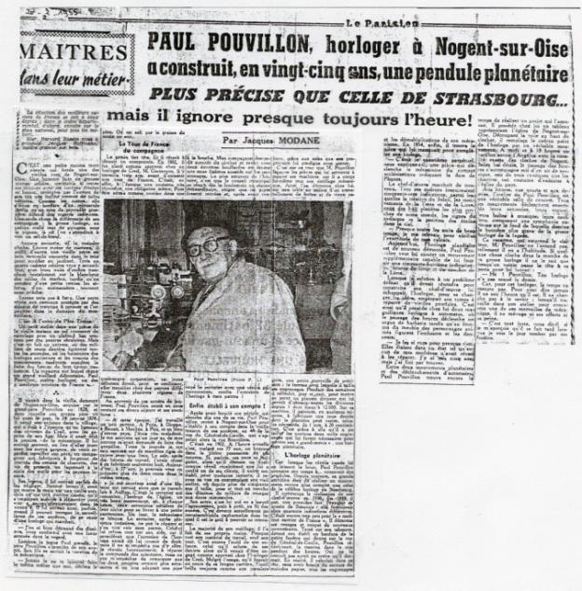

**Below is a translation of the newspaper article on the prior page, 20 February, 1955.**

**Masters in their Craft.**

Paul Pouvillon, clockmaker in Nogent-sur-Oise built, over twenty-five years, an astronomical clock more accurate than that in Strasbourg …… but he almost never knows what time it is!

It’s a simple little house off one of the old roads of Nogent-sur-Oise. A poky little house made of large solid stones, similar to all the neighbouring houses, with low narrow windows, protected by the overhang of its very steep roof covered in decayed tiles. The house, like all the others, towers over a minuscule strip of garden that a wall of rough pebbles protects from prying eyes. One thing alone sets it apart from its companions: the large clock, with its face crookedly fixed under the apex of the roof, where you might otherwise expect to see a bull’s-eye window.

No bell-push, in fact no bell at all. Even less a knocker. All that’s needed to gain entry into the small garden is to push open an old worm-eaten wooden door set into the wall. Three or four sun-dials welcome you, with their lines of shadow brutally slicing across the whiteness of the marble tables, whilst at the summit of a small outhouse, the blades of an anemometer turn ceaselessly.

Still three steps left. Push through a square-glazed door protected by curtains of cretonne *<Cretonne is a heavy printed cotton fabric>*, and you’re in the kingdom of marvels.

**It’s the cave of Old Father Time**

A small workshop in a room of the house with the floor covered in tiles and with a low ceiling held up by centuries-old beams. But it is, after all, a universe in which thousands of toothed wheels stretch out every second, where the pendulums of ancient clocks and the springs of modern movements mark the passing of the hours with their monotonous tick-tock.

A kingdom over which reigns a debonair grand old man, Paul Pouvillon, Master Clockmaker, one of the “Best Craftsmen of France”.

He was born in the old house, bought by grandfather Pouvillon in 1828, and in which his own father was living on that very day, the 24th of January 1878. He spent his childhood in the village, which at the time was little more than a hamlet in the area around Creil, with the other kids of his age. However, he already had a passion for mechanics. He often, instead of going out to play with the other boys, came in and watched his father working; a journeyman who spent all day long making buggy axles, press-screws, or shaping by hand tools for the local peasants.

He sometimes neglected his lessons, especially if he’d managed to get his hands on an old clock, or a broken watch, to which he would immediately apply himself in order to take them apart to see “What they had in their belly”. Sometimes, when he managed to evade to vigilance of his elders, he managed to get hold of a clock that worked.

* I must have put tens of them out of order, he confides with an amused tinkle in his eye. *<”I must have wrecked dozens” might be better, but tens are used in the French>*

As the young Paul grew up, Father Pouvillon became worried about his future. His son had an aptitude for mechanics.

Never will I let him do the same job as I, declared the father. You’re filthy with grease from morning to night !

**The Journeyman’s “Tour de France”**

The lad stuck to his guns, and managed to reach a compromise. In 1892 he was placed as an apprentice with a clockmaker in Creil, M. Coutançon. He worked there for three years before making a start on his tour of France. It was, after all, in those days a widespread custom, almost an obligation. In order to be admitted as a worker in any sort of Company, *<Company in the old sense of the word, as in the worshipful company of…..*> a young beginner had, in order to prove himself, to go and work with different masters in many regions of France.

At the memory of these years of youth, Paul Pouvillon smiles and relates his various stays and adventures:

In those days, I worked pretty well everywhere. In Paris, in Dieppe, in Rouen, Moulins, Pau, and in many other regions. I was very clumsy. I remember one day one of my bosses asked me to make taper pins *<the word used is goupilles – could also be other sorts of pins>*. All day I struggled over some accursed rods of copper with a file. That evening, after ten hours of work, I managed to make only eight. Today, at 77 years of age, I could whistle you up over two hundred in the same time. I can also remember something that happened whilst I was working in Auffay. It was the Locksmith who wound the church clock, a very fine movement, where, on every hour, two automata would come out of their niche in order to perform a short pantomime. One day, the mechanism seized up. The locksmith, after many attempts, couldn’t repair it, and came to see my employer. This latter refused point blank to come to his aid, as he felt that the maintenance of the clock should have been his prerogative from the outset, but didn’t stop me going. Fortunately, I succeeded in repairing the control of the automata, but I couldn’t help remarking that the two dolls would be much more amusing if they had a pipe in their mouths. My companion came straight down off the clock-tower, and came back with two enormous foam pipes which we proceeded to fix to the figures. The funniest part of the whole story is that the town council met the next day in emergency session, demanded that the pipes be removed, and after sacking the locksmith with a severe admonition, confided the maintenance of the clock to my employer!

**Finally set up on his own account!**

After having completed his tour, which took up ten years of his life, Paul Pouvillon returned to Nogent-sur-Oise to set himself up on his own account in the old house of his ancestors, at 48 rue du General-de-Gaulle, which was then called rue Bonvillers  
That was in 1902. Even now he is, despite his 77 years, a man in full possession of his faculties. If, sometimes, whilst he’s dissecting some recalcitrant alarm-clock, his eyes become tired, he quits his bench for a few moments. He rests his sight, contemplating his old workshop, where for over 50 years, he’s been cutting, placing, and setting going tens of thousands of wheels with minuscule teeth.  
He himself has set out the arrangement of his cubby hole *<The word used is antre - translates as den/cave/cubbyhole>*, little by little, with the passing of the years. It’s now become a fantastic hoard and jumble *<The word used is Capharnaüm – quite unusual…>* in which he’s the only one who can find his way.  
Most of his tools, he’s made with his own hands. Almost all his equipment, except his lathe. That’s still the tool of his childhood, the one he bought with his own money when he’d just been engaged as an apprentice with the clockmaker in Creil. Despite the use which it gave over its long career, the tool still shines as it did in the first days, thanks to the loving care lavished on it by its owner.  
It’s on this lathe that M. Pouvillon shaped the parts that he used to assemble these machines, because he conceived all his mechanical tools himself. Thus, can be found, on a table amongst a heap of boxes and old papers, a small mechanical marvel: the drill press *<I assume he actually means a milling machine or wheel cutting engine, but he says “drill”>* with which he cuts his gears. For weeks, he thought, day and night, in order to perfect a dividing plate *<most likely actually rotary table>* that would allow him to obtain all divisions from 1 to 12000. On this machine, he can, in only a few minutes, make a toothed wheel whose diameter can vary, depending on need, from 1mm to 20cm. It’s thanks to this machine that he was able to cut the almost two thousand gears which he needed to assemble his “magnum opus” , an astronomical clock. *This number is a great exaggeration, unless he is counting the teeth of each wheel*

**The Astronomical Clock**

Because, whenever the broken alarm clocks leave him some spare time, Paul Pouvillon spends his time……. designing clocks. From the beginning, his grand ambition was to design a movement even more complete that that of the famous clock of Strasbourg.  
He started the design of his masterpiece in 1930. In 1939 he was able, for the first time, to display it in the museum of Beauvais: at that time it gave forty different indications. That still wasn’t enough for the “Best Craftsman of France”. He disassembled his wheel-work and designed new movements. Perched on his stool, in front of his bench by the little window that looks over the rue General-de-Gaulle, Pouvillon thought deeply, head held low, for hours. Anyone who didn’t know him could well have thought that he was asleep. In actual fact, he was calculating, in his head, without the slightest need for recourse to paper, all the gears and reduction ratios of his mechanism. Finally, in 1954, he came up with the piece that was missing for him to complete his clock - It was the perpetual day-of-the-month *<the translator of the other newspaper article used the word “quantum” – “day-of-the-month” is a better translation for quantieme >* – he explains, a piece that triggers the mechanism of the ecclesiastical calculator which indicates the date of Easter. *This is the final piece he added to the Easter calculator making this subsystem perpetual, that is taking into account leap years for a 400 year period. (the next step is a further complication to make a calculator good for 1000 years, which this does not have).*  
The masterpiece was working once more. All its dials provided fifty-seven different indications, amongst which: The rotation of the Sun, the movement of the Earth and the moon, those of the eight planets closest to our world, the signs of the Zodiac and the position of the stars in the sky.  
- Almost every clear night, I’d get up to check the accuracy of my calculations. *We count about fourty but we only count all of the orrery as one, the tellurian as one plus some moon functions, whereas Pouvillon counted each planet as a separate complication.*

Today, the astronomical clock is once more in pieces. Paul Pouvillon wants to add a further movement able to provide a fifty-eighth indication – the times of the rising and setting of the Moon. *We have no evidence of this ever having been completed.*  
When the solution to a delicate problem which he had to solve in order to construct his master piece escaped him, the clockmaker, to change his outlook on things, passed his time repairing old clocks. Thus, he has in his house two magnificent automaton clocks, where the passing of the hours sets off a Barbary organ, whilst at the front of the case, animated figures make up the orchestra and the dancers.  
- I got them for next to nothing. They were in such a state that none of my colleagues had managed to repair them. It took me five years, but I found a way.

Between two astronomical movements, and the setting off of the automata, Paul Pouvillon still found the time to take on a project that kept him amused. He has at home a painting showing the church of Nogent-sur-Oise. Cutting out the canvas at the top of the clock tower, he replaced the painted dial of the clock with a real movement. At midday and 6pm, a peal of bells rings the Angelus with the exact tones of the bells of Nogent. At will, the passing of the hours is accompanied either by a musical tune, or by three popular songs that the bards used to perform at the local church.  
On the hour, on the quarter hours and on the half hours, Paul Pouvillon’s workshop is a real concert hall. All the movements set off their rings, their musical boxes, their chimes, all together, composing a curious symphony over the base of which the deeper tone of the bourdon *<a type of bell>* of the large clock from the façade dominates.  
M. Pouvillon doesn’t even hear this musical cacophony *<vacarne>*, so surprising to a visitor, so used is he to it. If something goes wrong with the running of his large clock, he only knows about it when a neighbour pops his head through the door to tell him:  
- Hey ! Pouvillon – your clock didn’t ring the half hour !

Because, for this clockmaker, time is of no consequence. That’s to say that he never knows what time it is. He never seeks to know; when he’s working in his workshop to come up with one of his mechanical wonders, he husbands neither his efforts nor his suffering.  
- It’s as much as can be expected, he tells us, if I notice that it’s late when I see the day coming to a close through my window.

**3. Article from the ANCAHA, Association Nationale des Collectionneurs et Amateurs d’ Horlogerie Ancienne, Number 43, 1985.**

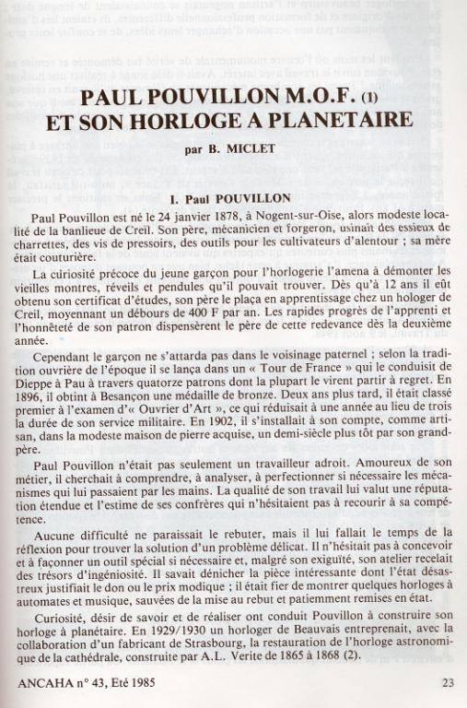

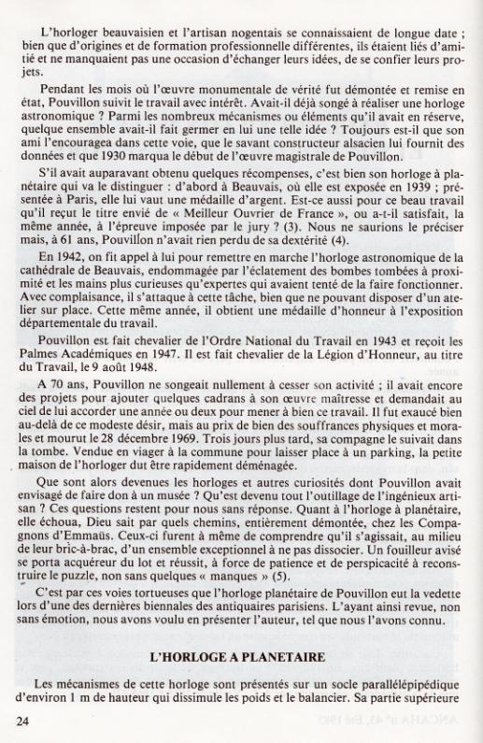

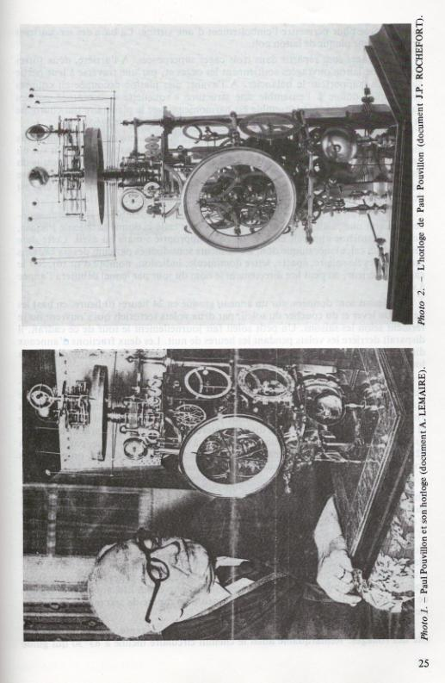

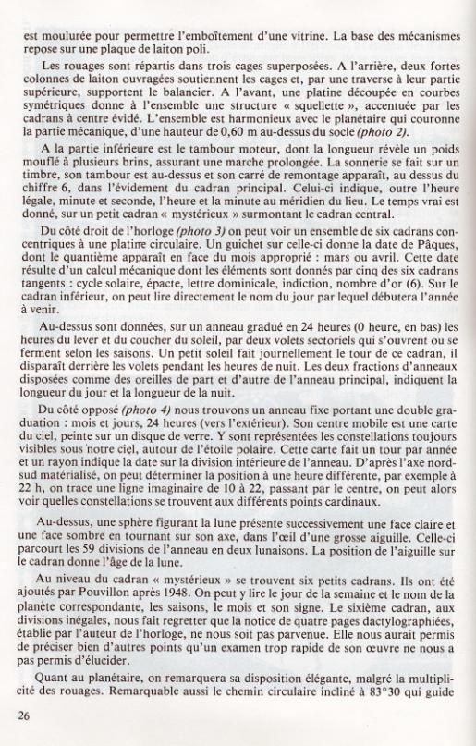

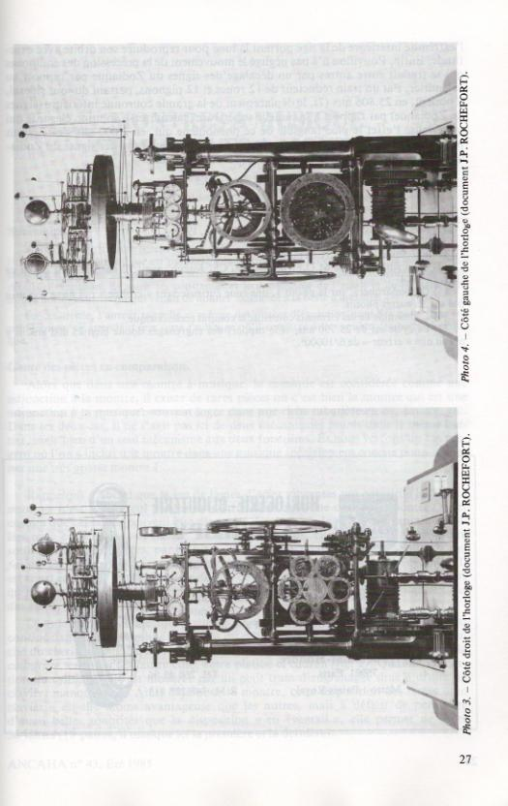

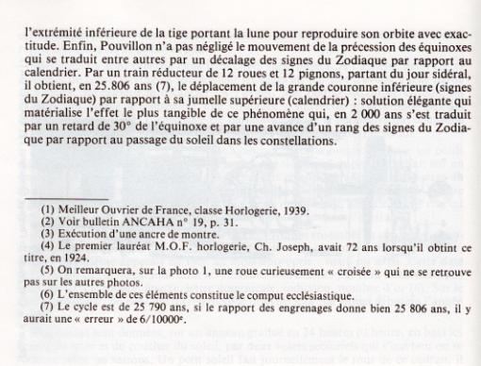

**Below is a translation of the French article from the ANCAHA Bulletin above.**

PAUL POUVILLON M.O.F. (1)

AND HIS

ORRERY CLOCK

Par B. MICLET

Mr. Paul Pouvillon was born on January 24th 1878 at Nogent sur Oise.

Very modest surrounding area of Creil, France. The father of Mr. Pouvillon was a mechanic by trade and was working in a factory making wheel axels for buggies, screws, and tools for farming equipment. His mother was seamstress.

Curiosity was a natural thing for Mr. Pouvillon, as a young boy he amused himself in taking apart old watches, clocks and carriage clocks. At the age of twelve he obtained his school degree. His father placed him in a training stage at a clock maker where he earned 400 FF annually. His rapid progress permitted him to stay at work for a second year, with his father’s consent.

During that time, the boy would not waste a minute staying around his home town. Traditional to the time, he traveled the entire country of France from Dieppe to Pau. "From North to South." He managed to work for fourteen clock makers and all of them regretted him leaving.

In 1896 received in Besancon a bronze medal. Two years later he was among the top of France’s awards for "Creative Craftsmanship" that reduced his military serving time from 3 years to 1 year. In 1902 he would start his own business as an artisan in a very modest stone house that once belonged to his grandfather.

Paul Pouvillon was not only a skilled worker that was talented, but he loved his work. He took the time to study, analyze and refine if necessary existing movements that passed through his hands. The quality of workmanship granted great respect from his peers of the days. There was never a project that was too difficult; it would only require his time and reflection to study every clock carefully. It was in his nature to often manufacture a special tool to repair a certain clock. His workshop was littered with creative tools that he had conceived in previous years. He would often be brought clocks and music boxes in nearly un-repairable condition and bring them back to life.

Curiosity and the will to learn inspired him to create the planetary clock. In 1929/1930 a clock maker friend that worked in Beauvais along with another friend from Strasbourg were in charge of maintaining and restoring the astronomical clock in Besancon, built by Auguste-Lucine Vérité, 1865 - 1868. (2) His clock friend from Beauvais was also an artisan often shared ideas and exchanged trade secrets. While the restoration work took place on the astronomical Besancon clock, all in parts....Pouvillon took a great interest on how the clock was built. Thus the idea of building his own astronomical clock was born. Over time his clock friend that was restoring the astronomical cathedral clock, noted all the major wheel works and shared them with Pouvillon.

The Pouvillon clock is the clock that got him notoriety when first exhibited in Beauvais in 1939. Afterward it was on exhibit in Paris where it won the silver medal. Because of this clock Pouvillon also received the same year the coveted award "Meilleur Ouvrier de France” or "Best Craftsman of France”, which is awarded only by his having to demonstrate his skills to a panel of judges. (3)

In 1942 he was called to restore the astronomical cathedral clock in Beauvais that had been damaged by the bombs that exploded nearby. By this time he was 61 years old and had lost none of his skills. (4) That same year he was awarded “médaille d’honneur a l’exposition” or “Best exhibition” in regards to his clock. Pouvillon is made a Knight of National Labor College in 1943 and receives Academic Palms in 1947 and was knighted, Legion of Honor in 1948.

At the age of 70 Pouvillon was still adding to the project and had in mind of adding three more dials to his famous clock. He asked God to give him once more year to finish is work. He lived longer than anticipated but suffered a great deal toward the end of his life. Pouvillon died on Dec 28, 1969, three days later his wife also died. His house was soon to be demolished for some parking lots and the contents of his house had to be moved quickly. What became of his other clocks and curiosities that he planned to donate to a museum? What became of all the tools of this ingenious artist? His clock was to be soon relocated to a new location. Thank God the clock did not suffer the same fate.

God only knows what road the Pouvillon clock has seen. The clock was completely dismantled at "The Friends of Emmaus” little did they know what they were taking apart. *The Emmaus is a type of charity organization popular in France and England. It would have a pararlell to the Salvation Army in the United States.* The clock laid there in pieces in a trashy workshop. A person snooping around had been tipped off of the clock lying in parts in the shop, and soon purchased all the parts and with lots of time and

patience got the clock rebuilt and with a few errors, working again. (5) *We have found and corrected these errors.*

It is through this tortuous path that the clock has recently come to be exhibited in the last Paris biennial antique dealers fair. We have thus reviewed, and not without emotion, the creator of this clock to the best of our knowledge.

THE GLOBAL (ASTRONOMICAL) CLOCK

"There is a remark that the is a wheel in picture 1, that is a curiously crossed out, is now missing and is not on the other pictures”. *We have deduced the function of this wheel. It and the associated cam pack disappeared sometime between the time of Pouvillon’s death in 1969 and the first time the clock reappears at the Jean-Pierre Rochefort clock dealer in September 1983*

The basic mechanisms rest on a polished brass plate. The wheels are divided into three stacked cages. At the rear, are two strong steel columns supporting the ornate cages, with cross supports at their upper stages; the support beams. At the front, a plate cut into curves having a symmetrical structure and gives to the set a "skeleton" look, accentuated by dials within a hollow center. All is harmonious with the planetary ringa mechanical part from a height of 0.60 m above the base (photo 2). *This is the tellurian, forming the uppermost structure and supported by the orrery below.*

The clock measures 1 meter and rests on polish metal.

The wheel works are set in three stages that are superimposed. *(Stacked one upon each other)*

The very large columns hold the entire cage comprised of its work along with the pendulum.

The bottom part consist of the winding that hold the weights of the clock for a prolong period of time. *The duration has been determined to be two weeks (15 days).*

The front dial has been cut out to give the appearance of a skeleton clock.

The main dial showed the legal meridian time for the region and the small dial above is for the real time. " Here mysterieux " *We now know this is an equation of time dial. Real time is actually ‘sun’ time.*

On the right side there are 6 dials along with a half dial showing signs of the Easter in their appropriate month March or April all determined with mechanical calculated 6 dial wheel works.

The six dials are: solar cycle, epact, dominical letter, indiction, golden number, and on the lowest dial you can read the date that Easter will fall the next year. *This is an ecclesiastical calculator also known as a ‘computis’.*

The bottom is made with a set of louvers that indicate the sunset and sun rise graduated in 24 hrs; indicating the night and day. The sun rise and sun set is all calculated based on the season of the year.

On the left of the clock there is a fixed ring double graduated rating, with months and 24 hours on the exterior. The center is the view of the heaven painted on glass. Where there are represented by their constellations; viewable from our point of view providing that we are looking from the Northern Hemisphere. The glass dial rotates once per year and there is a date that is indicated to show the date and time on how to adjust the map of the heavens. For example at 22 Hour, with the north and south axis imaginary line, 10 - 22 you can view all the cardinal point. *(This is the planisphere).*

Then there is a dial comprised of the moon facing the sun and dark side of the moon. The moon turns in on a very large hand. This is takes place in **59 division** of the ring in two lunar cycles. The large hand indicates the age of the moon. *Why he chose two instead of one lunar cycle, has to do with making the 29 ½ day cycle into whole days of 29 and 30 days in keeping with the ecclisiatical need to assign a feast to a particular day. A feast cannot be held on a half-day.*

Behind the real time *(equation dial)* or mystery dial there are 6 small dials that where added by Mr. Pouvillon in 1948. We can read the day of the week along with the corresponding name of the planet, season, month and its signs. *There are actually seven dials, one of which we still need to determine, the one with unequal divisions.*

The sixth dial, with unequal division is...........We regret to inform you that the author of this document of this clock has miss placed 4 pages pertaining to inner working and never reached us. It would have been immensely helpful to us to understand all its complications. *No kidding!*

As per the orrery, you will note the numerous set of wheels that portray the wonderful circular trajectory that is inclined at 83 degrees and 30 seconds that guides all the planets.

The moon trajectory is achieved with perfection without neglecting the movement the precession of the equinoxes that also is translated into the zodiac signs in reference to the calendar months.

With a train reduction of 12 wheels and 12 pinions starting with sidereal day, the clock in 25,806 years will reach its is sibling the small ring zodiac verses its twin on the outer ring calendar month. (7) This mathematical phenomena is based on a 2000 year cycle that translate in a retard of 30 degree on the equinoxes and a gain on the large zodiac ring in regards to the passage of the sun and its constellation.

The cycle should be 25, 790 years and the wheel of this clock produce 25, 806, giving a margin of error of 6/10000.

|  |
| --- |
| (1) Meilleur Ouvrier de France, Class Clockmaker, 1939 |
| (2) See bulletin ANCAHA No. 19, p. 31. |
| (3) Making a watch escapement. |
| (4) The first winner M.O.F. watches, Ch Joseph, was 72 when he won the title in 1924. |
| (5) Note on the photo 1, there is a curiously crossed wheel, which is not found on other photos. |
| (6) All of these parts comprise the ecclesiastical computation.  (7) As the actual cycle is 25,790 years, and the gear ratio gives 25 806, there would be a "error” of 6 parts in 10000. |

Following is information concerning Mr. Pouvillon’s home town:

The contact details are as follows

[c.heure@nogentsuroise.fr](mailto:c.heure@nogentsuroise.fr) she is the woman to whom I spoke and said she could put her hands on details / information but never came up with the goods. She did say that to her knowledge no technical information was available.

[www.nogerntsuroise.fr](http://www.nogerntsuroise.fr/) is the town hall site (maire)

0033 805 12 60 60 is the maire telephone

The person who got me this information said “It is my personal experience with French town halls (maire or hotel de ville) that help over the telephone or email is impossible, there also appears to be a built in reluctance to converse in English. However visits in person are always rewarding and information normally readily available, I would suggest that you have some Pouvillon reference with you to show the reason for your enquiries.”

This is the website contact for the 'Meilleur Ouvrier de France', M.O.F.

<http://www.meilleursouvriersdefrance.info/contact.php>

I have tried this contact using the Google translator and have not received a reply.

I have been incontact with ANCAHA, Association Nationale des Collectionneurs et Amateurs d’ Horlogerie Ancienne. They have provided me with an original publication of the article scanned above and have said they will poll their members in the next issue as to further information. This publication is not yet out.

**Below is a side by side translation of the ANCAHA article by B. Miclet:**

|  |  |
| --- | --- |
| PAUL POUVILLON M.O.F. (1)  ET SON HORLOGE A PLANETAIRE  Par B. MICLET | PAUL POUVILLON M.O.F. (1)  AND HIS  ORRERY CLOCK  Par B. MICLET |
|  |  |
| 1. **Paul POUVILLON**   Paul Pouvillon est né le 24 janvier 1878, à Nogent-sur-Oise, alors modeste localité de la banlieue de Creil. Son père, mécanicien et forgeron, usinait des essieux de charrettes, des vis de pressoirs, des outils pour les cultivateurs d’alentour ; sa mère était couturière. | 1. Paul POUVILLON   Pouvillon Paul was born on 24 January 1878 at Nogent-sur-Oise, a small town in the suburb of Creil. His father, a mechanic and blacksmith, made axles for carts, screw presses and tools for local growers; his mother was a seamstress. |
|  |  |
| La curiosité précoce du jeune garçon pour l’horlogerie l’amena à démonter les vieilles montres, réveils et pendules qu’il pouvait trouver. Dès qu’à 12 ans il eût obtenu son certificat d’études, son père plaça en apprentissage chez un horloger de Creil, moyennant un débours de 400 F par an. Les rapides progrès de l’apprenti et l’honnêteté de son patron dispensèrent le père de cette redevance dès la deuxième année. | The early curiosity of the young boy for watches led him to dismantle any old watches and alarm clocks that he could find. When he was 12 years old and had obtained his certificate of education, his father paid for him to be apprenticed to a watchmaker in Creil, at a cost of 400 F per year. Due to the rapid progress of the apprentice and the honesty of his master, his father’s payment of this fee was waivered in the second year. |
|  |  |
| Cependant le garçon ne s’attarda pas dans le voisinage paternel; selon la tradition ouvrière de l’époque il se lança dans un <<Tour de France>> qui le conduisit de Dieppe à Pau à travers quatorze dont la plupart le virent partir a regret. En 1896, il obtint à Besançon une médaille de bronze. Deux ans plus tard, il était classe premier a l’examen d’<<Ouvrier d’Art>>, ce qui réduisait a une année au lieu de trois la durée de son service militaire. En 1902, il s’installait à son compte, comme artisan, dans la modeste maison de pierre acquise, un demi-siècle plus tôt par son grand-père. | But the young man did not continue to work with his patron; as was the tradition of the time, instead he set out on a "Tour of France" which led to Dieppe in Pau working for fourteen different employers, most of whom saw him leave with regret. In 1896, in Besançon he obtained a bronze medal. Two years later, he came first in his professional examinations for "Ouvrier d'Art", which reduced his military service to one year instead of three. In 1902 he started working for himself, as a craftsman, in a modest stone house bought half a century earlier by his grandfather. |
|  |  |
| Paul Pouvillon n’était pas seulement un travailleur adroit. Amoureux de son métier, il cherchait a comprendre, à analyser, à perfectionner si nécessaire les mécanismes qui lui passaient par les mains. La qualité de son travail lui valut use réputation étendue et l’estime de ses confrères qui n’hésitaient pas à recourir a sa compétence. | Paul Pouvillon was not only a skilful worker. In love with his job, he sought to understand, analyse and perfect, where necessary, the movements that passed through his hands. The quality of his work earned him the respect and esteem of his colleagues who did not hesitate to call on his expertise. |
|  |  |
| Aucune difficulté ne paraissait le rebuter, mais il lui fallait le temps de la réflexion pour trouver la solution d’un problème délicat. Il n’hésitait pas concevoir et a façonner un outil spécial si nécessaire et, malgré son exiguïté, son atelier recelait des trésors d’ingéniosité. Il savait dénicher la pièce intéressante dont l’état désastreux justifiait le don ou le prix modique ; il était fier de montrer quelques horloges à automates et musique, sauvées de la mise au rebut et patiemment remises en état. | He never gave in to difficulties, but spent the time needed for reflection to find the solution to a difficult problem. He did not hesitate to design and fabricate special tools as necessary and, despite its small size, his studio was a treasure trove of ingenuity. He would find interesting examples in a poor state that he was given or which were cheap; he was proud to show a few clocks with automata and music, that he saved from scrapping and had patiently repaired. |
|  |  |
| Curiosité, désir de savoir et de réaliser ont conduit Pouvillon à construire son horloge a planétaire. En 1929/1930 un horloger de Beauvais entreprenait, avec la collaboration d’un fabricant de Strasbourg, la restauration de l’horloge astronomique de la cathédrale, construite par A.L. Verite de 1865 à 1868 (2). | Curiosity, and a desire to understand and achieve led Pouvillon to build an orrery clock. In 1929/1930 a clockmaker from Beauvais undertook, in collaboration with a manufacturer from Strasbourg, the restoration of the astronomical clock in the cathedral that was constructed by A. L. Verite between 1865 to 1868 (2). |
|  |  |
| L’horloger beauvaisien et l’artisan nogentais se connaissaient de longue date ; bien que d’origines et de formation professionnelle différentes, ils étaient liés d’amitié et ne manquaient pas une occasion d’échanger leurs idées, de se confier leurs projets. | The Beauvaisien clockmaker and the artisan from Nogent had known each other for a long time, even though their backgrounds and training were different, they were friends and never wasted an opportunity to exchange ideas and discuss each other’s projects. |
|  |  |
| Pendant les mois ou l’œuvre monumentale de vérité fut démontée et remise en état, Pouvillon suivit le travail avec intérêt. Avait-il déjà songe à réaliser une horloge astronomique ? Parmi les nombreux mécanismes ou éléments qu’il avait en réserve, quelque ensemble avait-il fait germer en lui une telle idée ? Toujours est-il que son ami l’encouragea dans cette voie, que le savant constructeur alsacien lui fourni des données et que 1930 marqua le début de l’œuvre magistrale de Pouvillon. | Over the course of several months the massive clock was dismantled and refurbished, and Pouvillon followed its progress with interest. Had he ever thought to make an astronomical clock? What amongst the many movements or parts that he had observed was the instigation for such an idea? However, his friend encouraged him in this direction, that the knowledgeable Alsatian provided him with data, which in 1930 marked the beginning of Pouvillon’s brilliant work. |
|  |  |
| S’il avait auparavant obtenu quelque récompenses, c’est bien son horloge à planétaire qui va le distinguer : d’abord à Beauvais, ou elle est exposée en 1939 ; présentée à Paris, elle lui vaut une médaille d’agent. Est-ce aussi pour ce beau travail qu’il reçut le titre envie de <<Meilleur Ouvrier de France>>, ou a-t-il satisfait, la même année, à l’épreuve imposée par le jury ? (3). Nous ne saurions le préciser mais, à 61 ans, Pouvillon n’avait rien perdu de sa dextérité (4). | If he had previously obtained some recognition, it is his orrery clock that distinguished Pouvillon: first at Beauvais, where it was shown in 1939, and then in Paris, where it was awarded a silver medal. Was it also for this outstanding piece of work that he received the coveted title of "Finest Worker in France", or had he in the same year satisfied the examination imposed by the assessors? (3). We cannot be sure, but at 61, Pouvillon had lost none of his skill (4). |
|  |  |
| En 1942, on fit appel à lui pour remettre en marche l’horloge astronomique de la cathédrale de Beauvais, endommagée par l’éclatement des bombes tombées à proximité et les mains plus curieuses qu’expertes qui avaient tenté de la faire fonctionner. Avec complaisance, il s’attaque à cette tache, bien que ne pouvant disposer d’un atelier sur place. Cette même année, il obtient une médaille d’honneur à l’exposition départementale du travail. | In 1942, it appealed to him to repair the astronomical clock in the cathedral of Beauvais, damaged by bombs that fell nearby and the tinkering of more curious than expert hands who had tried to make it work. With great care, he tackled the task even though he was not provided with a workshop there. The same year, he received a medal of honour in an exhibition by the Departmental of Work. |
|  |  |
| Pouvillon est fait chevalier de l’Ordre National du Travail en 1943 et reçoit les Palmes Académiques en 1947. Il est fait chevalier de la Légion d’Honneur, au titre du Travail, le 9 aout 1948. | Pouvillon was made ​​a Knight of l’Ordre National du Travail in 1943 and received the Palmes Académiques in 1947. He was a Knight of the Légion d’Honneur, under the work category, on August 9, 1948. |
|  |  |
| A 70 ans, Pouvillon ne songeait nullement à cesser son activité ; il avait encore des projets pour ajouter quelques cadrans à son œuvre maitresse et demandait au ciel de lui accorder une année ou deux pour mener à bien ce travail. Il fut exauce bien au-delà de ce modeste désir, mais au prix de bien des souffrances physiques et morales et mourut le 28 décembre 1969. Trois jours plus tard, sa compagne le suivait dans la tombe. Vendue en viager à la commune pour laisser place à un parking, la petite maison de l’horloger dut être rapidement déménagée. | A 70-year Pouvillon had no intention of stopping work; he still planned to add a few more dials to his masterpiece and prayed that heaven would grant him a year or two to complete this work. His prayer was granted beyond his modest wish, but at the cost of both physical and mental health and he died on 28 December 1969. Three days later his wife followed him to the grave. Sold “en viager” (which means he got a pension from the buyer until his death against the ownership of the house after his death), the small house of the clockmaker was quickly emptied by the local council and demolished to make way for a car park. |
|  |  |
| Que sont alors devenues les horloges et autres curiosités dont Pouvillon avait envisage de faire don à un musée? Qu’est devenu tout l’outillage de l’ingénieux artisan ? Ces questions restent pour nous sans réponse. Quant à l’horloge a planétaire, elle échoua, Dieu sait par quels chemins, entièrement démontée, chez les Compagnons d’Emmaüs. Ceux-ci furent a même de comprendre qu’ils s’agissait, au milieu de leur bric-à-brac, d’un ensemble exceptionnel à n pas dissocier. Un fouilleur avisé se porta acquéreur du lot et réussit, à force de patience et de perspicacité à reconstruire le puzzle, non sans quelques <<manques>> (5). | What then became the clocks and other curiosities Pouvillon had planned to donate to a museum? What became of all the tools of the ingenious craftsman? These questions remain unanswered. As for the orrery clock, it ended in the Companions of Emmaus, God knows why, completely dismantled. They understood how exceptional the lot was and kept it together. A clever amateur bought it and succeeded with patience and insight to reconstruct the puzzle with a few errors (5). |
|  |  |
| C’est par ces voies tortueuses que l’horloge planétaire de Pouvillon eut la vedette lors d’une dernière biennale des antiquaires parisiens. L’ayant ainsi revue, non sans émotion, nous avons voulu en présenter l’auteur, tel que nous l’avons connu. | This was the tortuous path that had brought Pouvillon’s orrery clock to be featured in the last Parisian antique dealers fair. Having thus reviewed the clock, not without emotion, we wanted to present its creator and its background as best we can. |
|  |  |
| **L’HORLOGE A PLANETAIRE** | **ORRERY CLOCK** |
|  |  |
| Les mécanismes de cette horloge sont présentés sur un socle parallélépipédique d’environ 1 m de hauteur qui dissimule les poids et le balancier. Sa partie supérieure est moulurée pour permettre l’emboitement d’une vitrine. La base des mécanismes repose sur une plaque de laiton poli. | The clock’s movement is set on a rectangular base about 1 m high, which conceals the weight and pendulum. Its upper part is shaped to allow the showcase to sit on it. The base of the movement sits on a sheet of polished brass. |
|  |  |
| Les rouages sont repartis dans trois cages superposées. A l’arrière, deux fortes colonnes de laiton ouvragées soutiennent les cages et, par une traverse a leur partie supérieure, supportent le balancier. A l’avant, une platine découpée en courbes symétriques donne a l’ensemble une structure <<squelette>>, accentuée par les cadrans a centre évide. L’ensemble est harmonieux avec le planétaire qui couronne la partie mécanique, d’une hauteur de 0,60 m au-dessus du socle (photo 2). | The movement is distributed across three frames, stacked one above the other. At the back, two large columns support ornate brass frames, and across their upper part, support the pendulum. The front plate is shaped with symmetrical curves which gives a skeleton structure, accentuated by the dials in the central recess. The whole is balanced by the orrery system that crowns the mechanical part, 0.60 m above the base (photo 2). |
|  |  |
| A la partie inferieure est le tambour moteur, dont la longueur révèle un poids moufle à plusieurs brins, assurant une marche prolongée. La sonnerie se fait sur un timbre, son tambour est au-dessus et son carre de remontage apparait, au dessus du chiffre 6, dans l’évidement du cadran principal. Celui-ci indique, outre l’heure légale, minute et seconde, l’heure et la minute au méridien du lieu. Le temps vrai est donne, sure un petit cadran <<mystérieux>> surmontant le cadran central. | At the lower level is the winding barrel for the going train. Its length is required for the endless rope system, ensuring a prolonged duration. The bell is a small one, its barrel is above it and the winding square is in the empty part of the dial above the number 6. This indicates, in addition to the standard time, minute and second the hour and minute of the local meridian. The true time is given, by a small "mystery" dial on top of the central dial. |
|  |  |
| Du côté droit de l’horloge (photo 3) on peut voir un ensemble de six cadrans concentrique à une platine circulaire. Un guichet sure celle-ci donne la date de Pâques, dont le quantième apparait en face du mois approprie : mars or avril. Cette date résulte d’un calcul mécanique dont les éléments sont donnes par cinq des six cadrans tangents : cycle solaire, épacte, lettre dominical, indiction, nombre d’or (6). Sur le cadran inferieur, on peut lire directement le nom du jour par lequel débutera l’année à venir. | On the right side of the clock (photo 3) we can see a set of six dials surrounding a circular plate. An aperture on this plate gives the date of Easter and the date (calendar) appears in front of the appropriate month: March or April. This date is the result of a mechanical calculation whose elements are given by five of the six surrounding dials: Solar Cycle, Epact, Dominical Letter, Indiction and Golden Number (6). On the lower dial, one can read directly the name of the first day of the following year. |
|  |  |
| Au-dessus sont données, sur un anneau gradue en 24 heures (0 heure, en bas) les heures du lever et du coucher du soleil, par deux volets sectoriels qui s’ouvrent ou se ferment selon les saisons. Un petit soleil fait journellement le tour de ce cadran, il disparait derrière les volets pendent les heures de nuit. Les deux fractions d’anneaux disposées comme des oreilles de part et d’autre de l’anneau principal, indiquent la longueur du jour et la longueur de la nuit. | Above this is on a 24 hours dial (0 hours at the bottom) are given the hours of sunrise and sunset, by two shutters that open or close depending on the season. A small sun makes a daily tour of the dial, and disappears behind the shutters during the night hours. The two partial dials, arranged like ears on either side of the main ring, indicate the length of day and the length of the night. |
|  |  |
| Du côté oppose *(photo 4)* nous trouvons un anneau fixe portant une double graduation : mois et jours, 24 heures (vers l’extérieur). Son centre mobile est une carte du ciel, peinte sur un disque de verre. Y sont représentées les constellations toujours visibles sous notre ciel, autour de l’étoile polaire. Cette carte fait un tour par année et un rayon indique la date sur la division intérieure de l’anneau. D’après l’axe nord-sud matérialisé, on peut déterminer la position à une heure différent, par exemple à 22 h, on trace une ligne imaginaire de 10 à 22, passant par le centre, on peut alors voir quelles constellations se trouvent aux différents point cardinaux. | On the opposite side *(photo 4)* we find a fixed dial with a double scale: months and days, and 24 hours (outer scale). Its centre is a rotating star chart painted on a glass disk. This shows the visible constellations in northern hemisphere that surround the Pole Star. This chart makes one revolution per year and a marker indicates the date on the division of the inner ring. From the north-south axis, we can determine the position of the stars at a different time, eg. 22:00, by drawing an imaginary line from 10:00 to 22:00, passing through the centre, and one can see which constellations can be found at different cardinal points. |
|  |  |
| Au-dessus, une sphère figurant la lune présente successivement une face claire et une face sombre en tournant sur son axe, dans l’œil d’une grosse aiguille. Celle-ci parcourt les 59 divisions de l’anneau en deux lunaisons. La position de l’aiguille sur le cadran donne l’âge de la lune. | Above this dial there is a sphere representing the moon, having bright and dark sides, which turns on its axis in the eye of a large needle. It moves through the 59 divisions of the ring in two lunar months. The position of the needle on the dial gives the age of the moon. |
|  |  |
| Au niveau du cadran <<mystérieux>> se trouvent six petits cadrans. Ils ont été ajoutes par Pouvillon après 1948. On peut y lire le jour de la semaine et le nom de la planète correspondante, les saisons, le mois et son signe. Le sixième cadran, aux divisions inégales, nous fait regretter que la notice de quatre pages dactylographiées, établie par l’auteur de l’horloge, ne nous soit pas parvenue. Elle nous aurait permis de préciser bien d’autres points qu’an examen trop rapide de son œuvre ne nous a pas permis d’élucider. | At the level of the “mystery” dial are six small dials. They were added by Pouvillon after 1948. They indicate the day of the week and the name of the planet corresponding to the season, month, and its sign. The sixth dial, with unequal divisions, makes us regret that we did not receive the four typewritten pages of notes, prepared by the maker of the clock. These would have clarified many other points that a brief examination of his work did not elucidated. |
|  |  |
| Quant au planétaire, on remarquera sa disposition élégante, malgré la multiplicité des rouages. Remarquable aussi le chemin circulaire incline à 83o30 qui guide l’extrémité inferieure de la tige portant la lune pour reproduire son orbite ave exactitude. Enfin, Pouvillon n’a pas négligé le mouvement de la précession des équinoxes qui se traduit entre autres par un décalage des signes du Zodiaque par rapport au calendrier. Pau un train réducteur de 12 roues et 12 pignons, partant du jour sidéral, il obtient, en 25,806 ans (7), le déplacement de la grande couronne inferieure (signes du Zodiaque) par rapport a sa jumelle supérieure (calendrier) : solution élégante qui matérialise l’effet le plus tangible de ce phénomène qui, en 2 000 ans s’est traduit par un retard de 30o de l’équinoxe et par une avance d’un rang des signes du Zodiaque par rapport au passage du soleil dans les constellations. | As for the orrery, we can see its elegant layout, despite the complexity of wheels. Also remarkable is the 83o30 inclined circular path that guides the lower end of the rod attached to the moon to accurately reproduce its orbit. Finally, Pouvillon did not neglect the motion of the precession of the equinoxes, resulting among others by a shift in calendar of the signs of the Zodiac. By a reduction train of 12 wheels and 12 pinions, based on the sidereal day, he achieves in 25,806 years (7) the displacement of the large lower ring (Zodiac signs) compared to its twin upper ring (calendar): an elegant solution, which results in the most tangible effect of this phenomenon that over 2,000 years there is 30o delay in the equinox and an advance among the signs of the Zodiac of the passage of the sun in constellations. |
|  |  |
| 1. Meilleur Ouvrier de France, classe Horlogerie, 1939 | (1) Meilleur Ouvrier de France, Class Clockmaker, 1939 |
| 1. Voir bulletin ANCAHA no 19, p. 31. | (2) See bulletin ANCAHA No. 19, p. 31. |
| 1. Exécution d’une ancre de montre. | (3) Making a watch escapement. |
| 1. Le premier lauréat M.O.F. horlogerie, Ch. Joseph, avait 72 ans lorsqu’il obtint ce titre, en 1924. | (4) The first winner M.O.F. watches, Ch Joseph, was 72 when he won the title in 1924. |
| 1. On remarquera, sur la photo 1, une roue curieusement <<croisée>> qui ne se retrouve pas sur les autres photos. | (5) Note on the photo 1, there is a curiously crossed wheel, which is not found on other photos. |
| 1. L’ensemble de ces éléments constitue le comput ecclésiastique. computation. | (6) All of these parts comprise the ecclesiastical |
| 1. Le cycle est de 25 790 ans, si le rapport des engrenages donne bien 25 806 and, il y aurait une <<erreur>> de 6/10000e. | (7) As the actual cycle is 25,790 years, and the gear ratio gives 25 806, there would be a "error” of 6 parts in 10000. |